HAEMODIALYSIS

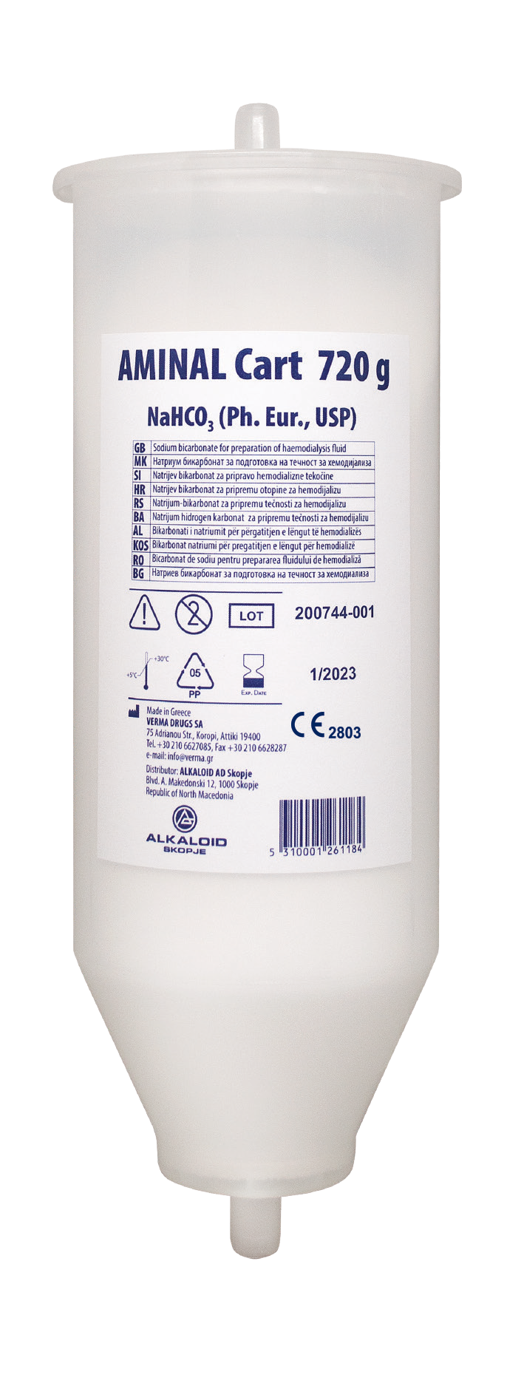

**FOR PROFESSIONAL USE ONLY**

AMINAL Cart

Sodium Bicarbonate Cartridge - NaHCO3



AMINAL Cart

Sodium Bicarbonate Cartridge - NaHCO3

|  |  |  |  |  |  |  |  |  |  |  |
| --- | --- | --- | --- | --- | --- | --- | --- | --- | --- | --- |
| **TECHNICAL DATA** | | | | | | | | | | |
| **Description** | **AMINAL Cart sodium bicarbonate cartridge for haemodialysis** | | | | | | | | | |
| 620 g | 650 g | 720 g | 750 g | 760 g | 900 g | 950 g | 1000 g | 1100 g | 1150 g |
| **Product code** | CART.050 | CART.060 | CART.057 | CART.052 | CART.053 | CART.058 | CART.055 | CART.054 | CART.051 | CART.059 |
| **Composition** | **Sodium Bicarbonate powder NaHCO3** | | | | | | | | | |
| **Intended use** | **On line production of liquid bicarbonate concentrate of haemodialysis** | | | | | | | | | |
| **Packaging per carton** | 10 pcs | 10 pcs | 10 pcs | 10 pcs | 10 pcs | 8 pcs | 8 pcs | 8 pcs | 8 pcs | 8 pcs |
| **Compatible with** | Gambro [AK10, AK200, AK200S, AK200S ULTRA, AK90, AK95, AK96, AK98, Phoenix,  Artis Physio], Hospal [Integra], B.Braun [Dialog+, Dialog IQ], Bellco [Formula, Flexya (factory option)], Nikkiso [DBB-03, DBB-05, DBB-06, DBB-07, DBB-EXA], Nipro  [Surdial 55plus (factory option), Surdial X, NCU-18, DIAMAX (factory option)], Dialife [Dianova, Dianova X2] | | | | | Gambro [AK10, AK200, AK200S, AK200S  ULTRA, AK96, AK98, Phoenix, Artis Physio], B.Braun [Dialog+, Dialog IQ], Bellco [Formula, Flexya (factory option)], Nikkiso [DBB-03, DBB-05, DBB-06, DBB-07,  DBB-EXA], Nipro [Surdial 55plus (factory option), DIAMAX (factory option)], Dialife [Dianova, Dianova X2] | | | | |
| **Shelf life** | **36 months** | | | | | | | | | |
| **Storage conditions** | **5ºC - 30ºC** | | | | | | | | | |

The product is in compliance with the requirements of European Pharmacopoeia and USP.





**2803**

Version 02 from 05.2023.

[**www.alkaloid.com.mk**](http://www.alkaloid.com.mk/)

PHARM A CEUTIC AL CHEMIC AL C OSMETIC INDUSTR Y

Blvd. Aleksandar Makedonski 12, Skopje Repubilc of North Macedonia Tel.: +389 2 31 04 041; Fax.: +389 2 31 04 041